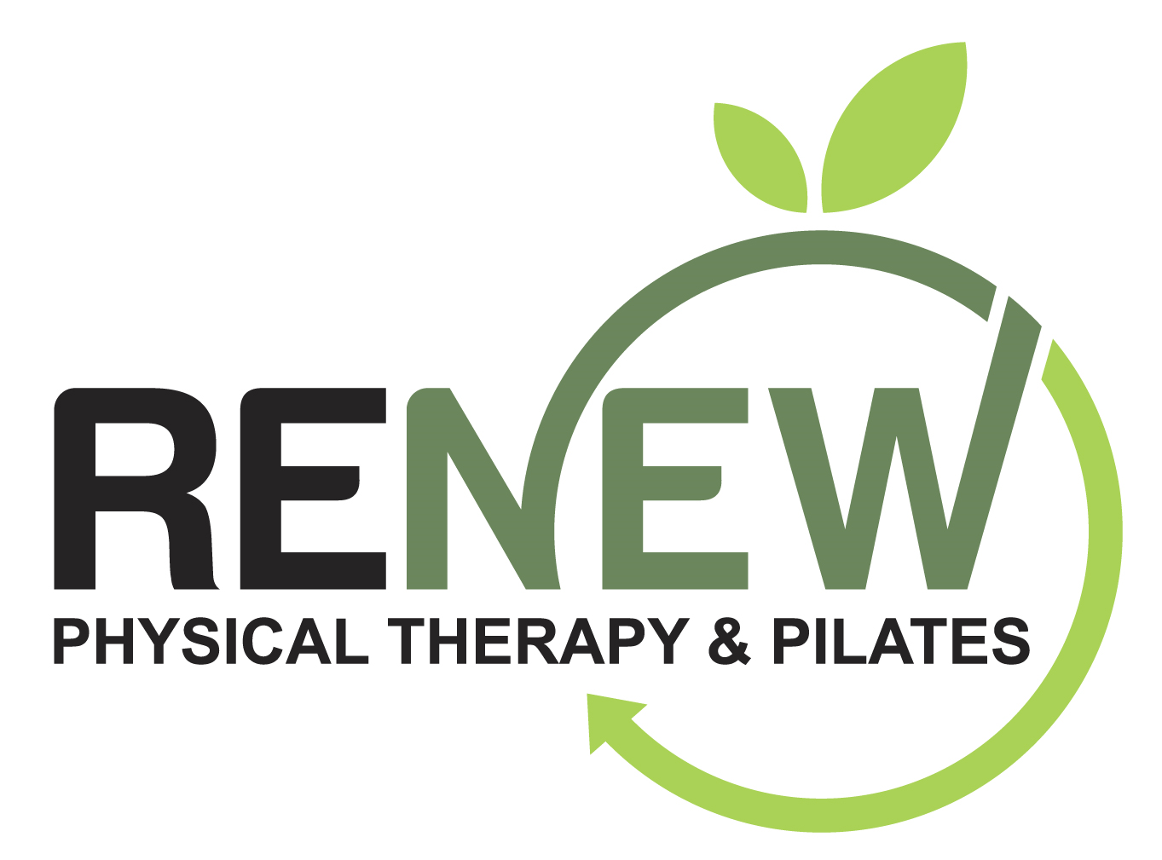
Renew Physical Therapy & Pilates COVID-19 Policies and Procedures
Renew Physical Therapy & Pilates Friends, Clients and Neighbors,
Our state and county have eased restrictions and are allowing us to open with specific guidelines. During this COVID-19 lockdown, we have become experts on disinfecting, sanitizing, social distancing, and DORA (Department of Regulatory Agency) guidelines. We are doing everything we can to remain open for business, keep you and all of us safe and healthy, and prevent the need for future restrictions and closures. These regulations and processes are designed to get you in and out safely and efficiently while maintaining 6’ of separation and limiting shared common area contact points.
Please do not put yourself, your family, or others at risk. We realize how challenging it has been to stay at home and limit your human contact. If you answer YES to any of the following questions, we respectfully ask that you not come to the studio at this time:
1. Have you recently traveled out of the country?
2. Have you had contact with anyone with confirmed COVID-19 in the last 14 days?
3. Do you have any of the following symptoms: fever above 100.0, difficulty breathing, or cough?
Our Policies & Procedures:
· All clients and service providers will be required to wear a face mask at all times, upon entry, and covering both nose and mouth at all times.
· Wear sticky socks in the studio for hygiene and safety, launder after each use
· No food or drink in the studio
· Please arrive alone, no children or observers allowed at this time
· Maintain a minimum of 6’ social distancing at all times, if classes are not full, please alternate Reformers and CoreAligns to allow for more than 6’ of distancing.
· All small group classes will be staggered to avoid congestion at the front entry upon arrival & departure.
· Appointment times will be staggered in an attempt to avoid congestion upon entering & exiting, to allow for thorough cleaning between appointments
· Please do not enter before your scheduled time and be aware of others entering with you, maintaining social distancing measures
· We ask that you limit your time outside of your appointment or class time here at the studio and refrain from using the bathroom, when possible.
· We are requiring a contactless payment experience so a credit or debit card will be required to be on file to avoid shared contact of cards, pens, cash or checks.
· Every week we have Enviro-Master’s Virus Vaporizer electrostatic spraying service done which uses an EPA registered disinfectant to kill disease-causing pathogens including COVID-19, Norovirus, Influenza, etc.
· We have Medifyair HEPA filters throughout Renew Physical Therapy & Pilates. One in each of the treatment rooms, an office HEPA and a studio HEPA which runs 24 hours a day cleaning the air you breathe.
Upon Entering the studio:
· Remove shoes and place in storage bench
· Answer 3 screening questions
· Thoroughly clean hands with hand sanitizer
· Non-contact temporal temperature check (if > 100.0 you will be asked to leave and not return for 14 days)
CLASS PARTICIPANTS
· Please fill Reformers and CoreAligns from the back of the studio first to avoid congestion at the entry areas and to maintain social distancing. If you choose you may pre-clean your Reformer with provided cleansers while others continue to be checked in. All Reformers are cleaned at the end of each use and disinfected at the end of each day. If class is not full, please alternate Reformers or CoreAligns to allow for more than 6’ of distance.
· A hand towel will be provided for your personal use. You may also bring one from home
· To maintain safe social distancing, please carry any conversations outside of the front of the studio after class to avoid congestion at the entry area.
PRIVATE CLIENTS / PHYSICAL THERAPY PATIENTS
· After entry screening is completed, please proceed to the treatment room indicated by your screener.
· While we have missed you tremendously, due to social distancing guidelines, you will be required to exit the premises as soon as your class/session is complete in order to clean thoroughly before the next person.
* Even with all precautions in place, there is still risk involved in coming to our studio. If you are over 65 and/or have health issues that put you at higher risk, we encourage you to decide if this activity, at this time, is a priority.
We require that all clients sign our COVID-19 Waiver / Hold Harmless Release prior to your first visit with us at Renew Physical Therapy & Pilates. We would prefer you sign, scan, and send back to us prior to your first visit to avoid shared pens and congestion at the entry area.
Stay safe. Stay well.
Renew Physical Therapy & Pilates

COVID-19 RELEASE OF LIABILITY / HOLD HARMLESS RELEASE
In exchange for participation in the activity of semi-private personal training, Pilates instruction, and physical therapy services at Renew Physical Therapy & Pilates, LLC at 8182 S. Holly Street, Centennial, CO 80122.

I, (print clearly)_____________________________________agree for myself to the following:

1. AGREEMENT TO FOLLOW DIRECTIONS. I agree to observe and obey all posted rules and warnings, and further agree to follow any oral instructions or directions given by Renew Physical Therapy & Pilates and all service providers.

2. ASSUMPTION OF THE RISKS AND RELEASE. I recognize that there are certain inherent risks associated with the above described activity and I assume full responsibility for personal injury to myself and further release and discharge Renew Physical Therapy & Pilates, LLC from injury, loss or damage arising out of my use of or presence upon the facilities of Renew Physical Therapy & Pilates, LLC. whether caused by the fault of myself, Renew Physical Therapy & Pilates, LLC or other third parties.

3. INDEMNIFICATION. I agree to indemnify and defend Renew Physical Therapy & Pilates, LLC against all claims, causes of action, damages, judgments, costs or expenses, including attorney fees and other litigation costs, which may in any way arise from my use of or presence upon the facilities of Renew Physical Therapy & Pilates, LLC

4. APPLICABLE LAW. Any legal or equitable claim that may arise from participation in the above shall be resolved under Colorado law.

5. NO DURESS. I agree and acknowledge that I am under no pressure or duress to sign this Agreement and that I have been given a reasonable opportunity to review it before signing. I further agree and acknowledge that I am free to have my own legal counsel review this Agreement if I so desire.

6. ARM'S LENGTH AGREEMENT. This Agreement and each of its terms are the product of an arm's length negotiation between the Parties. In the event any ambiguity is found to exist in the interpretation of this Agreement, or any of its provisions, the Parties, and each of them, explicitly reject the application of any legal or equitable rule of interpretation which would lead to a construction either "for" or "against" a particular party based upon their status as the drafter of a specific term, language, or provision giving rise to such ambiguity.

7. ENFORCEABILITY. The invalidity or unenforceability of any provision of this Agreement, whether standing alone or as applied to a particular occurrence or circumstance, shall not affect the validity or enforceability of any other provision of this Agreement or of any other applications of such provision, as the case may be, and such invalid or unenforceable provision shall be deemed not to be a part of this Agreement.

8. I understand that Renew Physical Therapy & Pilates, LLC and all practitioners are not held liable for any exposure to COVID-19.

9. I understand that even with cleaning, sanitizing, and disinfecting protocols, wearing of masks by all parties, 6’ social distancing, and limiting the studio occupancy to no more than 10 at one time, there is an inherent risk in entering Renew Physical Therapy & Pilates in the current climate of COVID-19 spread. I enter into this knowing my risks.

______________________________________________ ______________________
PRINTED NAME DATE

______________________________________________
SIGNATURE

Revised 11/6/20

