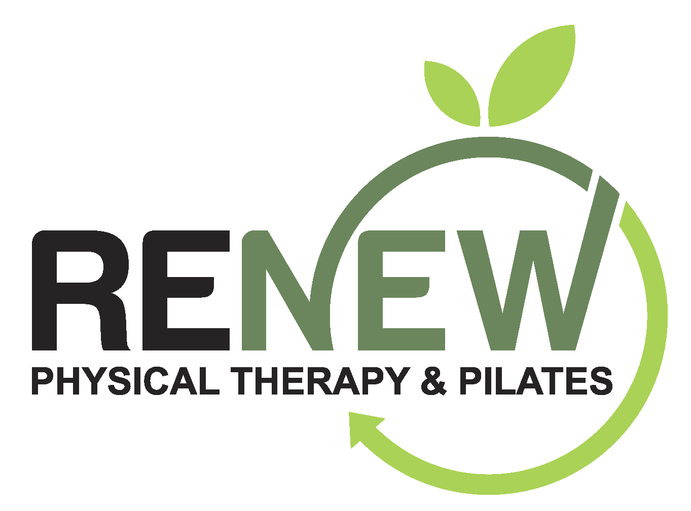
Renew Physical Therapy & Pilates COVID-19 Policies and Procedures
Our goal at Renew Physical Therapy & Pilates, is to work within the most current guidelines set forth by the CDC and our local Tri County Health Department based on the real time COVID-19 numbers in our immediate area and surrounding communities. The safety of our staff and clients will always be front and center in our policy decisions.
Renew Physical Therapy Policies & Procedures as of November 24, 2021:
Effective Nov. 24: Public Health Order requiring face coverings for all individuals 2 years of age and older in public indoor spaces. Review the full order and additional resources on our Public Health Order page.
We will continue to follow the mask mandate for Pilates group classes as well as private Pilates sessions and all physical therapy visits until at least January, 2022. At that time, we will follow any additional public health orders from Tri County Health and err on the side of caution through the winter and early spring months.

The staff at Renew Physical Therapy & Pilates is fully vaccinated for all of our protection. We will all continue to mask up at all times regardless of vaccination status for the foreseeable future.

We request if you are not feeling 100%, you cancel your appointments.

We strongly encourage hand sanitizing upon entering the studio.

Wear sticky socks in the studio for hygiene and safety, launder after each use (we have loaners)

A personal water bottle is allowed.

Please do not enter more than 5 minutes before your class or appointment start time to avoid congestion at the entry area.

We require a contactless payment system with a credit card be on file to limit shared pens and limit contact points as well as congestion at the front of the studio.

Twice weekly Enviro-Master’s Virus Vaporizer electrostatic commercial cleaning service which uses an EPA registered disinfectant to kill disease-causing pathogens including COVID-19, Norovirus, Influenza, etc.

Continuous use of Medifyair HEPA filters throughout Renew Physical Therapy & Pilates. One in each treatment room, in the staff office, and two studio HEPA systems to clean the air.
*We all still assume increased risk each time we are in a public, indoor space with people of different households. If you are unvaccinated, over 65 and/or are immunocompromised, we encourage you to decide if this activity, at this time, is safe and appropriate.
We require that all clients sign our COVID-19 Waiver/Hold Harmless Release. We also require signing of our Mask Liability Waiver. You may choose to respectfully decline to declare your vaccination status. Please understand our need to ask so we know how close we are to the desired 95% vaccination rate in our place of business so we can consider exemption status if the mask mandate continues into 2022.

Stay safe. Be well.
Renew Physical Therapy & Pilates

COVID-19 RELEASE OF LIABILITY / HOLD HARMLESS RELEASE
In exchange for participation in the activity of semi-private personal training, Pilates instruction, and physical therapy services at Renew Physical Therapy & Pilates, LLC at 8182 S. Holly Street, Centennial, CO 80122.

I, (print clearly)_____________________________________agree for myself to the following:

1. AGREEMENT TO FOLLOW DIRECTIONS. I agree to observe and obey all posted rules and warnings, and further agree to follow any oral instructions or directions given by Renew Physical Therapy & Pilates and all service providers.

2. ASSUMPTION OF THE RISKS AND RELEASE. I recognize that there are certain inherent risks associated with the above described activity and I assume full responsibility for personal injury to myself and further release and discharge Renew Physical Therapy & Pilates, LLC from injury, loss, or damage arising out of my use of or presence upon the facilities of Renew Physical Therapy & Pilates, LLC. whether caused by the fault of myself, Renew Physical Therapy & Pilates, LLC, or other third parties.

3. INDEMNIFICATION. I agree to indemnify and defend Renew Physical Therapy & Pilates, LLC against all claims, causes of action, damages, judgments, costs, or expenses, including attorney fees and other litigation costs, which may in any way arise from my use of or presence upon the facilities of Renew Physical Therapy & Pilates, LLC

4. APPLICABLE LAW. Any legal or equitable claim that may arise from participation in the above shall be resolved under Colorado law.

5. NO DURESS. I agree and acknowledge that I am under no pressure or duress to sign this Agreement and that I have been given a reasonable opportunity to review it before signing. I further agree and acknowledge that I am free to have my own legal counsel review this Agreement if I so desire.

6. ARM'S LENGTH AGREEMENT. This Agreement and each of its terms are the product of an arm's length negotiation between the Parties. In the event, any ambiguity is found to exist in the interpretation of this Agreement, or any of its provisions, the Parties, and each of them, explicitly reject the application of any legal or equitable rule of interpretation which would lead to construction either "for" or "against" a particular party based upon their status as the drafter of a specific term, language, or provision giving rise to such ambiguity.

7. ENFORCEABILITY. The invalidity or unenforceability of any provision of this Agreement, whether standing alone or as applied to a particular occurrence or circumstance, shall not affect the validity or enforceability of any other provision of this Agreement or of any other applications of such provision, as the case may be, and such invalid or unenforceable provision shall be deemed not to be a part of this Agreement.

8. I understand that Renew Physical Therapy & Pilates, LLC and all practitioners are not held liable for any exposure to COVID-19.

9. I understand that even with cleaning, sanitizing, and disinfecting protocols, wearing of masks by all parties, 6’ social distancing, and limiting the studio occupancy to no more than 10 at one time, there is an inherent risk in entering Renew Physical Therapy & Pilates in the current climate of COVID-19 spread. I enter into this knowing my risks.

______________________________________________ ______________________
PRINTED NAME DATE

______________________________________________
SIGNATURE
Mask Liability Waiver

> I acknowledge that despite the easing of CDC and governmental mask mandate rules, I will follow the local mask rules and regulations while at Renew Physical Therapy & Pilates, LLC.

> I am aware of the mask policy and COVID safety protocols at Renew Physical Therapy & Pilates, LLC.

> I acknowledge and understand that at the signing of this waiver COVID-19 has not been eradicated, it is a highly contagious airborne virus, and by choosing to engage in indoor activities in a public setting, I may be increasing my risk of contracting the virus.

> I understand that as of 11/24/2021 the local health department, Tri County Health, has put in place a public health order mandating the wearing of facial coverings at all times while in public indoor settings regardless of vaccination status due to the high numbers of infections and hospitalizations in our immediate area.

> I will not hold Renew Physical Therapy & Pilates, LLC liable in regards to COVID-19.

Check One:
____ I am fully vaccinated for COVID-19 (1 dose of Johnson & Johnson / 2 doses of Moderna/Pfizer + BOOSTER)

____ I am not and do not intend to become vaccinated for COVID-19. I accept any and all risks associated with that decision.

____________________________________________ _____________
PRINT NAME DATE

____________________________________________
SIGNATURE

